System Architecture Blueprint and Module Design: Healthcare Cybersecurity

Written Assignment Unit 3

University of The People

MSIT-5910-01 –AY2026-T4 | Capstone Project

Professor: Shabia Shabir

Wednesday April 29, 2026

System Architecture Blueprint and Module Design
System Components
The system projected is designed as a layered healthcare cybersecurity platform. It focuses on risk assessment, treats, compliance, and incident responses, while being able to report it. The system architecture allows healthcare organizations to proactively manage cybersecurity risks, while ensure the compliance with healthcare regulations are maintained.
In the architecture below, it demonstrates a multi-layer approach consisting of user, application, security, and data layers. Each layer interacts with each other to ensure a secure processing, monitoring, and storage of sensitive healthcare-related metadata. All aspects work together to reduce the exposure of electronic protected health information (ePHI).
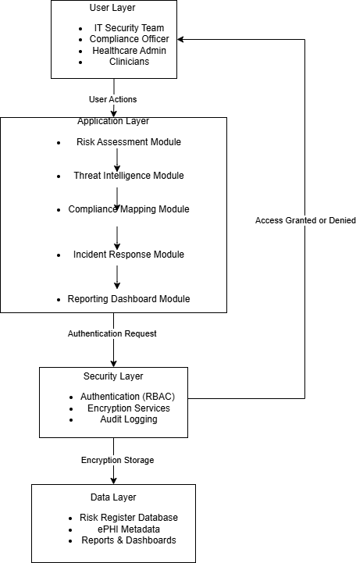
Module Breakdown
As technology has exponentially increased in healthcare organizations, most are often left exposed when it comes to cybersecurity. This isn’t a reflection of their effort, but it is a missing structure. Many hospitals or clinics still don’t have a clear process in place to help identify, assess, or respond to many cybersecurity risks. Without proactive plans in place, it creates a vulnerability to ransomware, phishing attacks, insider misuse, and data breaches. It is not caused by one failure either, but instead, it is the accumulation of several gaps. Missing a proper system architecture containing a formal risk register, threat model, and a proper incident response plan can cause the organization to become vulnerable. Because of this, the organization should create and maintain a more organized system-wide approach tying everything together, instead of adding standalone tools as patches.
The proposed system architecture leans into the idea of using a modular, layered design that aligns with existing frameworks such as the National Institute of Standards and Technology (NIST) and Health Insurance Portability Accountability Act (HIPAA) as they help provide a disciplined approach for managing risks by “identifying threats and vulnerabilities, impacts” (NIST, 2012). Instead of isolated tools, it combines the five key components, risk assessment, threat intelligence, compliance mapping, incident response, and reporting dashboards as one connected system. Data flows from each part in a logical sequence. Risks are identified and scored, provided with real-time threat awareness, which are checked against compliance requirements, and monitoring for any red flags that could trigger a response. Ultimately, everything appears on a dashboard, making the information easier to understand and act on, especially for operational leaders who need a clear picture without getting buried in technical details.
- User layer
  - IT and Cybersecurity Team
    - Implement and manage security
  - Compliance Team and Healthcare Administration
    - Enforce HIPAA compliance
  - Clinicians
    - Uphold data security and service
- Application layer
  - Risk Assessment Module
    - Input: Collect asset inventory, vulnerabilities, and any data threats
    - Output: Risk scores and a prioritized list
    - Methodology: likelihood vs impact model
  - Intelligence Module
    - Input: Database threats
    - Output: Threat scenarios and attack vectors
    - Methodology: STRIDE model approach
  - Compliance Mapping Module
    - Input: Regulatory standards: NIST and HIPAA requirements, system policies
    - Output: Compliance checklist and gap analysis
    - Methodology: Control mapping between NIST and HIPPA as well as policy validation
  - Incident Response Module
    - Input: Security alerts and detected incidents
    - Output: Response plans and recovery workflows
    - Methodology: NIST Incident response and automated workflows
  - Reporting Dashboard Module
    - Input: Data from all previous modules
    - Output: Visual dashboards, reports, and analytics
    - Methodology: Data aggregation and visual tools
- Security Service Layer
  - RBAC authentications
    - Input: User credentials
    - Output: Access
    - Methodology: Role-Based Access (RBAC) and multi-factor authentication
  - Encryption
    - Input: ePHI
    - Output: Encrypted data
    - Methodology: Hashing
  - Auditing
    - Input: User activity and system events
    - Output: Monitor and compliance logs
    - Methodology: Continuous logging

Functional and Non-Functional Requirements
In order to understand if the needs and expectations are met for end users, it is important to identify it when designing a system during the requirement analysis phase. Functional and non-functional requirements play a significant role in influencing how everything actually works.
Functional requirements focus on what the system should do defining “the specific features and operations a system must perform to meet business and user needs” (GeekforGeeks, 2026). Essentially, the are the core features that make the system useful. Functional requirement includes:
- identifying potential threats
- authorizing users to securely access the platform
- prioritize cybersecurity risks
- mapping compliance standards such as the NIST and HIPAA requirements
- detect, log, and respond to incidents
- generate dashboards
Non-functional requirements focus on how the system performs those tasks, focusing on the system “performance, reliability, and user experience rather than specific features” (GeekforGeeks, 2026). While these are not as visible as functional requirements, they are important because if a system works in theory, but is slow and unreliable, it won’t help healthcare systems. Non-functional requirements typically consist of performance, security, usability, reliability, scalability, maintainability, and portability.
- Performance – risk assessments and reports are generated within an acceptable time
- Security – encryption, RBAC, secure authentication
- Usability – intuitive dashboard for non-technical healthcare staff
- Reliability – system should maintain high availability
- Scalability – system should support on and off peak hours as expected

Version Control
A Git version control system was implemented utilizing GitHub to help manage the project development and ensure traceability, while supporting structured collaboration. This repository organized clearly defined directories that include folder for design, diagrams, documents, references, and reports. Each folder was given a placeholder to be able to commit, over wise nothing was pushed. In this structure, it creates an organized structure to facilitate managing project assets in the lifecycle.
Branching strategy separates stable and work in progress. The main branch contains final versions of the project. The development branch is used for ongoing updates and modifications. Two feature branches, feature/risk-module and feature/compliance-mapping, were added to create isolated and specific components of the system. With this, is allows changes to be developed and tested independently without compromising the main branch. Clear commit messages such as “add project structure with file” and “add system architecture diagram” were utilize to document the process. This allows a transparent history of changes, making it easier to track development progress over time. Version control “enables frictionless communication, change, and reproducibility between developers and other team members” (GitLab, n.d.). This creates consistency, prevents data loss, and allows easily users to easily revert to previous versions.
Overall using Git increases project organization and traceability. This aligns with software engineering best practices creating a structured workflow. Project components are properly documents and maintained throughout the development process.

Resources
National Institute of Standards and Technology. (2012 September). Guide for Conducting Risk Assessments (NIST Special Publication 800-30 Rev. 1). U.S. Department of Commerce. https://nvlpubs.nist.gov/nistpubs/legacy/sp/nistspecialpublication800-30r1.pdf
GeekforGeeks. (2026, April 11). Functional and Non Functional Requirements. https://www.geeksforgeeks.org/software-engineering/functional-vs-non-functional-requirements/
GitLab. (n.d.). What is Git Version Control?. https://about.gitlab.com/topics/version-control/what-is-git-version-control/

